IE 575 Homework 7

Eric Smith

2025-07-12

1.1 Explore the Data Set and Initial Neural Network Model
Data Exploration
# Load the dataset
file_path <- "Patient_Data.xlsx"
patient_data <- read_excel(file_path, sheet = "Patient Data")

# Check for missing values and duplicates
na_counts <- sapply(patient_data, function(x) sum(is.na(x)))
print("Missing Values in Each Column:")
## [1] "Missing Values in Each Column:"
print(na_counts)
## age gender diabetes smoker active
## 0 0 0 0 0
## obesity heartattack_s bp cholesteral
## 0 0 0 0
duplicate_count <- sum(duplicated(patient_data))
print(paste("Number of Duplicate Rows:", duplicate_count))
## [1] "Number of Duplicate Rows: 4492"
# Clean and factorize
patient_data <- patient_data[!duplicated(patient_data), ]

categorical_vars <- c("gender", "diabetes", "smoker", "active", "obesity", "heartattack_s", "bp", "cholesteral")
patient_data[categorical_vars] <- lapply(patient_data[categorical_vars], factor)

# Overview
summary(patient_data)
## age gender diabetes smoker active obesity
## Min. :45.00 Female:1766 No :3024 No :2398 No :1851 No :2298
## 1st Qu.:55.00 Male :1740 Yes: 482 Yes:1108 Yes:1655 Yes:1208
## Median :63.00
## Mean :63.28
## 3rd Qu.:71.00
## Max. :89.00
## heartattack_s bp cholesteral
## No :1445 Hypertension:1190 Highl :1566
## Yes:2061 Hypotension : 665 Normal:1940
## Normal :1651
##
##
##
str(patient_data)
## tibble [3,506 × 9] (S3: tbl_df/tbl/data.frame)
## $ age : num [1:3506] 54 64 63 67 76 69 67 74 69 54 ...
## $ gender : Factor w/ 2 levels "Female","Male": 1 1 1 2 2 2 2 2 2 1 ...
## $ diabetes : Factor w/ 2 levels "No","Yes": 1 1 1 1 1 1 2 1 1 1 ...
## $ smoker : Factor w/ 2 levels "No","Yes": 1 1 1 2 1 1 2 1 2 2 ...
## $ active : Factor w/ 2 levels "No","Yes": 2 1 1 1 1 1 2 1 2 1 ...
## $ obesity : Factor w/ 2 levels "No","Yes": 1 1 1 1 1 1 1 2 1 1 ...
## $ heartattack_s: Factor w/ 2 levels "No","Yes": 1 2 2 1 1 1 2 2 1 2 ...
## $ bp : Factor w/ 3 levels "Hypertension",..: 1 3 3 2 2 3 1 3 3 3 ...
## $ cholesteral : Factor w/ 2 levels "Highl","Normal": 2 2 1 1 2 2 2 2 1 1 ...
Data Set Observations
This is the same dataset from the last homework where there were no missing values, but that there were 4,492 duplicate rows.
Variables include age, which is continuous and numeric, and a number of classification variables, such as gender with female and male; diabetes, smoker, active, obesity, heartattack_s (the target variable), all with “Yes” or “No” classes; blood pressure (bp), with three classes that include “Hypertension,” “Hypotension,” and “Normal”; and and cholesterol with two classes that include “High,” and “Normal”.
And we initially looked as some charting last time and noted that, as expected, the classic indicators shown in the bar charts above show that expected risks such as diabetes and being a smoker have more observations of heart attack risk.

1.2 Create Neural Network Model
# Load the neuralnet package
if (!requireNamespace("neuralnet", quietly = TRUE)) install.packages("neuralnet")
library(neuralnet)
## Warning: package 'neuralnet' was built under R version 4.5.1
##
## Attaching package: 'neuralnet'
## The following object is masked from 'package:dplyr':
##
## compute
df <- patient_data

# Convert factors to numeric 0/1 (or 1/2/3 for bp)
df_clean <- df %>%
mutate(across(where(is.factor), ~ as.numeric(.) - 1)) # This makes 0 = "No", 1 = "Yes"

# Normalize age
df_clean$age <- scale(df_clean$age, center = TRUE, scale = TRUE)

# Check result
glimpse(df_clean)
## Rows: 3,506
## Columns: 9
## $ age <dbl[,1]> <matrix[26 x 1]>
## $ gender <dbl> 0, 0, 0, 1, 1, 1, 1, 1, 1, 0, 1, 0, 0, 0, 1, 0, 0, 1…
## $ diabetes <dbl> 0, 0, 0, 0, 0, 0, 1, 0, 0, 0, 0, 0, 0, 0, 0, 0, 0, 0, 0,…
## $ smoker <dbl> 0, 0, 0, 1, 0, 0, 1, 0, 1, 1, 0, 0, 1, 0, 1, 1, 0, 0, 1,…
## $ active <dbl> 1, 0, 0, 0, 0, 0, 1, 0, 1, 0, 1, 1, 0, 0, 1, 1, 1, 1, 0,…
## $ obesity <dbl> 0, 0, 0, 0, 0, 0, 0, 1, 0, 0, 0, 0, 1, 1, 0, 0, 0, 0, 0,…
## $ heartattack_s <dbl> 0, 1, 1, 0, 0, 0, 1, 1, 0, 1, 0, 0, 1, 0, 1, 1, 0, 0, 1,…
## $ bp <dbl> 0, 2, 2, 1, 1, 2, 0, 2, 2, 2, 2, 2, 2, 0, 2, 2, 2, 2, 2,…
## $ cholesteral <dbl> 1, 1, 0, 0, 1, 1, 1, 1, 0, 0, 1, 1, 1, 0, 0, 1, 1, 0, 1,…
# Build formula dynamically
feature_names <- names(df_clean)[names(df_clean) != "heartattack_s"]
f <- as.formula(paste("heartattack_s ~", paste(feature_names, collapse = " + ")))

# Build the neural network (try with one hidden layer of 5 nodes to start)
set.seed(42) # Set for reproducibility
nn <- neuralnet(f, data = df_clean, hidden = 5, linear.output = FALSE)

# Predict using the same data (since no split)
predicted <- compute(nn, df_clean[, feature_names])$net.result

# Convert probabilities to 0/1
predicted_class <- ifelse(predicted > 0.5, 1, 0)

# Confusion matrix and accuracy
table(Predicted = predicted_class, Actual = df_clean$heartattack_s)
## Actual
## Predicted 0 1
## 0 923 645
## 1 522 1416
mean(predicted_class == df_clean$heartattack_s)
## [1] 0.667142
# Calculate accuracy
accuracy <- mean(predicted_class == df_clean$heartattack_s)
print(paste("Neural Network Accuracy:", round(accuracy * 100, 2), "%"))
## [1] "Neural Network Accuracy: 66.71 %"
# Plot the neural network
plotnet(nn)
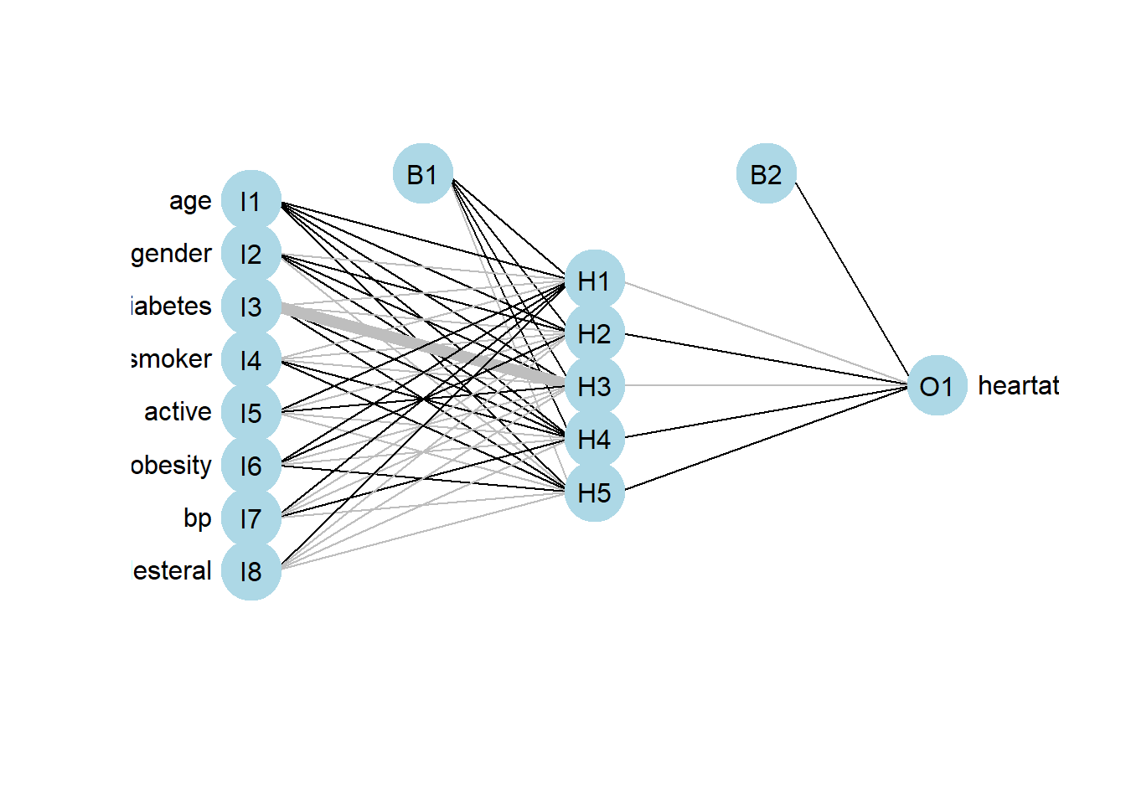
Fig 1. Initial Neural Network Model with a single hidden layer of 5 nodes.
# overall predictions
df_clean$prediction_prob <- predicted
df_clean$predicted_class <- predicted_class

ggplot(df_clean, aes(x = prediction_prob, fill = factor(heartattack_s))) +
geom_histogram(position = "identity", bins = 30, alpha = 0.6) +
labs(fill = "Actual Heart Attack", x = "Predicted Probability", y = "Count") +
ggtitle("Predicted Probability Distribution by Class")
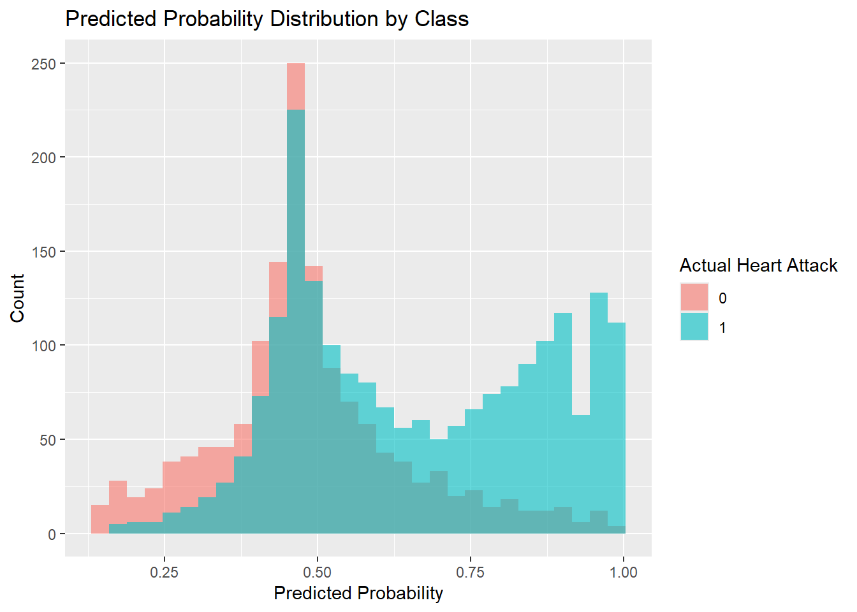
Fig 2. Neural Network overall predictions vs. actuals.
# Predictions by feature

# Keep only predictors + prediction
df_long <- df_clean %>%
select(-heartattack_s) %>%
mutate(predicted_class = factor(predicted_class)) %>%
pivot_longer(cols = -predicted_class,
names_to = "variable",
values_to = "value")

ggplot(df_long, aes(x = value, fill = predicted_class)) +
geom_density(alpha = 0.6, position = "identity") +
facet_wrap(~ variable, scales = "free", ncol = 3) +
labs(title = "Distributions of Predicted Classes Across All Features",
x = "Feature Value", fill = "Predicted\nClass") +
theme_minimal()
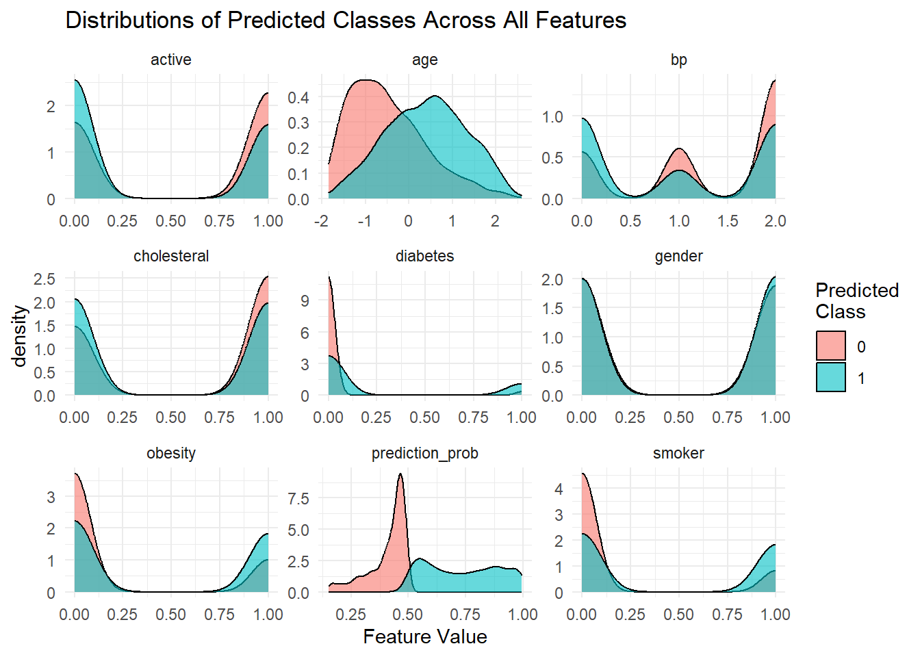
Fig 3. Neural Network feature predictions vs. actuals.
garson_vals <- garson(nn, bar_plot = FALSE)
print(garson_vals)
## rel_imp
## age 0.11292792
## gender 0.03315861
## diabetes 0.35169861
## smoker 0.15475818
## active 0.05206163
## obesity 0.09137532
## bp 0.12620563
## cholesteral 0.07781409
olden(nn)
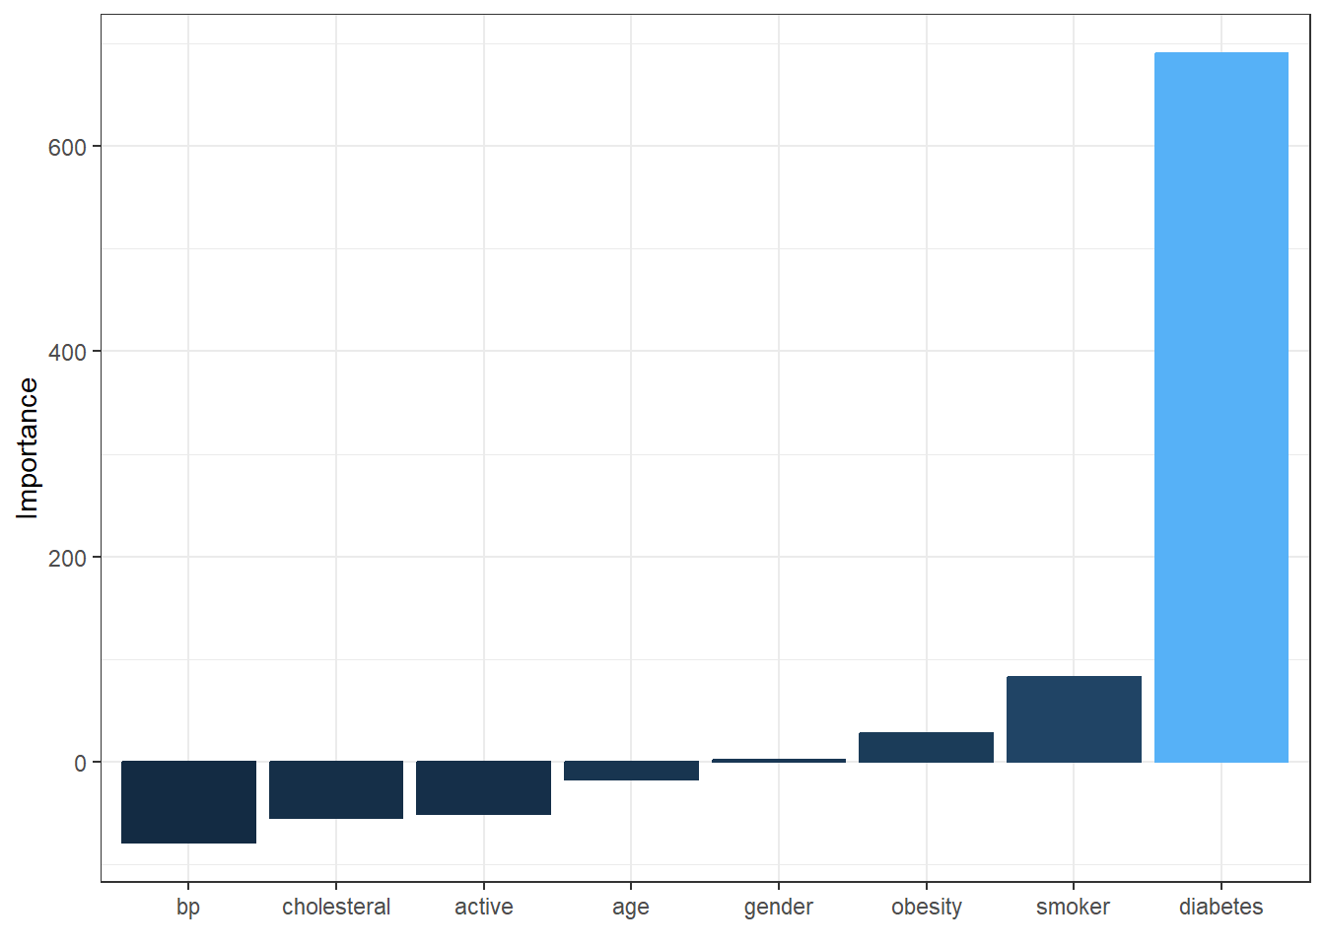
Fig 4. Feature importance from the neural network model.
# Evaluate performance using confusion matrix
nn_cm <- confusionMatrix(
factor(df_clean$predicted_class),
factor(df_clean$heartattack_s),
positive = "1"
)

# ROC and AUC
nn_roc <- roc(
response = df_clean$heartattack_s,
predictor = as.vector(df_clean$prediction_prob) # ensures numeric vector
)
## Setting levels: control = 0, case = 1
## Setting direction: controls < cases
auc_nn <- as.numeric(nn_roc$auc)

# Create a table for the neural network evaluation metrics
nn_eval_tbl <- data.frame(
Metric = c("Accuracy", "Sensitivity", "Specificity", "AUC"),
Value = c(
round(as.numeric(nn_cm$overall["Accuracy"]), 3),
round(as.numeric(nn_cm$byClass["Sensitivity"]), 3),
round(as.numeric(nn_cm$byClass["Specificity"]), 3),
round(auc_nn, 3)
)
)

# Display it as a nicely formatted table
knitr::kable(nn_eval_tbl, caption = "Table 1. Neural Network Model Evaluation Metrics")
Table 1. Neural Network Model Evaluation Metrics
Metric | Value
Accuracy | 0.667
Sensitivity | 0.687
Specificity | 0.639
AUC | 0.737
Neural Network Summary
To start, I created a basic neural network model to predict the likelihood of heart attack using eight input features. I used one hidden layer with five neurons. This simple structure helped keep the model easy to interpret while still giving it some flexibility to capture relationships in the data.
The model reached an accuracy of 66.7%, with a sensitivity of 68.7% and specificity of 63.9%. This means the model was slightly better at identifying people who actually had heart attacks than those who didn’t. The AUC was 0.737, which suggests the model did a decent job overall of separating the two classes.
When I looked at the histogram of predicted probabilities, people who had heart attacks mostly received higher probability scores. But there was still some overlap around the 0.4–0.6 range, where the model wasn’t as confident. These are the borderline cases where it struggled to make clear predictions.
To better understand how the model made decisions, we visualized its architecture and analyzed weight-based feature importance.
That analysis revealed that:
- Diabetes was by far the most influential predictor, contributing over a third of the model’s learned signal.
- Smoking status and blood pressure followed as the next most important features, with age also providing meaningful influence.
- Obesity, cholesterol, and activity level played more modest roles.
- Gender had the least impact on predictions.
Key Observations
- Model Performance: The model correctly classified about two-thirds of all cases. Its higher sensitivity suggests better detection of heart attack risk than avoidance of false alarms.
- Predicted Probabilities: The model generally assigned higher risk scores to actual heart attack cases, though predictions were less certain near the middle probability range. Histogram charting of predictions vs. actuals showed that the gender class had a good overlap in terms of appearing to be the most accurately predicted class.
- Feature Influence: The dominance of diabetes as a predictor, followed by smoking and blood pressure, suggests that lifestyle and medical history factors weigh heavily in the model’s risk assessment.

2.1 C5.0 Model
model <- C5.0(heartattack_s ~ ., data = patient_data)
summary(model)
##
## Call:
## C5.0.formula(formula = heartattack_s ~ ., data = patient_data)
##
##
## C5.0 [Release 2.07 GPL Edition] Sat Jul 12 05:50:01 2025
## -------------------------------
##
## Class specified by attribute `outcome'
##
## Read 3506 cases (9 attributes) from undefined.data
##
## Decision tree:
##
## diabetes = Yes: Yes (482/90)
## diabetes = No:
## :...smoker = Yes:
## :...age > 60: Yes (539/129)
## : age <= 60:
## : :...bp = Hypertension: Yes (129/37)
## : bp in {Hypotension,Normal}:
## : :...obesity = Yes: Yes (89/34)
## : obesity = No:
## : :...active = No: Yes (101/48)
## : active = Yes: No (126/52)
## smoker = No:
## :...age <= 55: No (513/177)
## age > 55:
## :...obesity = No:
## :...active = No: Yes (501/237)
## : active = Yes: No (486/223)
## obesity = Yes:
## :...age > 71: Yes (159/38)
## age <= 71:
## :...active = No: Yes (207/72)
## active = Yes:
## :...gender = Female: No (82/36)
## gender = Male: Yes (92/41)
##
##
## Evaluation on training data (3506 cases):
##
## Decision Tree
## ----------------
## Size Errors
##
## 13 1214(34.6%) <<
##
##
## (a) (b) <-classified as
## ---- ----
## 719 726 (a): class No
## 488 1573 (b): class Yes
##
##
## Attribute usage:
##
## 100.00% diabetes
## 86.25% age
## 86.25% smoker
## 52.57% obesity
## 45.49% active
## 12.69% bp
## 4.96% gender
##
##
## Time: 0.0 secs
C5imp(model, metric = "usage")
## Overall
## diabetes 100.00
## age 86.25
## smoker 86.25
## obesity 52.57
## active 45.49
## bp 12.69
## gender 4.96
## cholesteral 0.00
# Predict and confusion matrix
preds <- predict(model, patient_data)
c50_cm <- table(predicted = preds, actual = patient_data$heartattack_s)
c50_accuracy <- mean(preds == patient_data$heartattack_s)

print(c50_cm)
## actual
## predicted No Yes
## No 719 488
## Yes 726 1573
paste("C5.0 Accuracy:", round(c50_accuracy * 100, 2), "%")
## [1] "C5.0 Accuracy: 65.37 %"
# Step 1: Get prediction probabilities from C5.0 model
c50_probs <- predict(model, patient_data, type = "prob")

# Step 2: Add to your cleaned dataset
df_clean$c50_prob <- c50_probs[, 2] # Column 2 is probability of class "Yes"

# Step 3: Plot the predicted probabilities by actual class
ggplot(df_clean, aes(x = c50_prob, fill = factor(heartattack_s))) +
geom_histogram(position = "identity", bins = 30, alpha = 0.6) +
labs(fill = "Actual Heart Attack",
x = "C5.0 Predicted Probability of Heart Attack",
y = "Count") +
ggtitle("C5.0 Predicted Probability Distribution by Actual Class") +
theme_minimal()
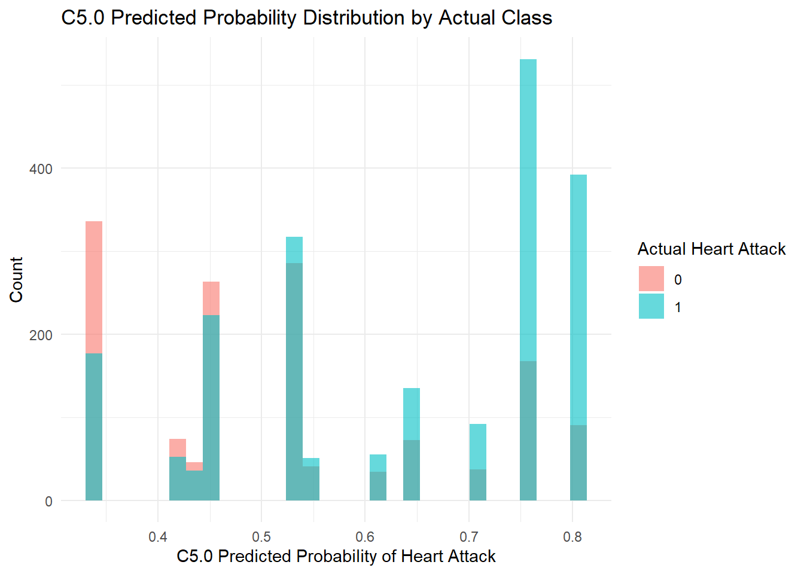
Fig 5. C5.0 overall predictions vs. actuals.
# Add predicted class from C5.0
df_clean$c50_predicted <- as.numeric(preds) - 1 # Convert to 0/1

# Pivot to long format for visualization
df_c50_long <- df_clean %>%
mutate(c50_predicted = factor(c50_predicted)) %>%
select(-heartattack_s) %>%
pivot_longer(cols = -c50_predicted,
names_to = "variable",
values_to = "value")

# Plot the cluster grid
ggplot(df_c50_long, aes(x = value, fill = c50_predicted)) +
geom_density(alpha = 0.6, position = "identity") +
facet_wrap(~ variable, scales = "free", ncol = 3) +
labs(title = "C5.0 Predicted Class Distributions by Feature",
x = "Feature Value", fill = "C5.0 Predicted\nClass") +
theme_minimal()
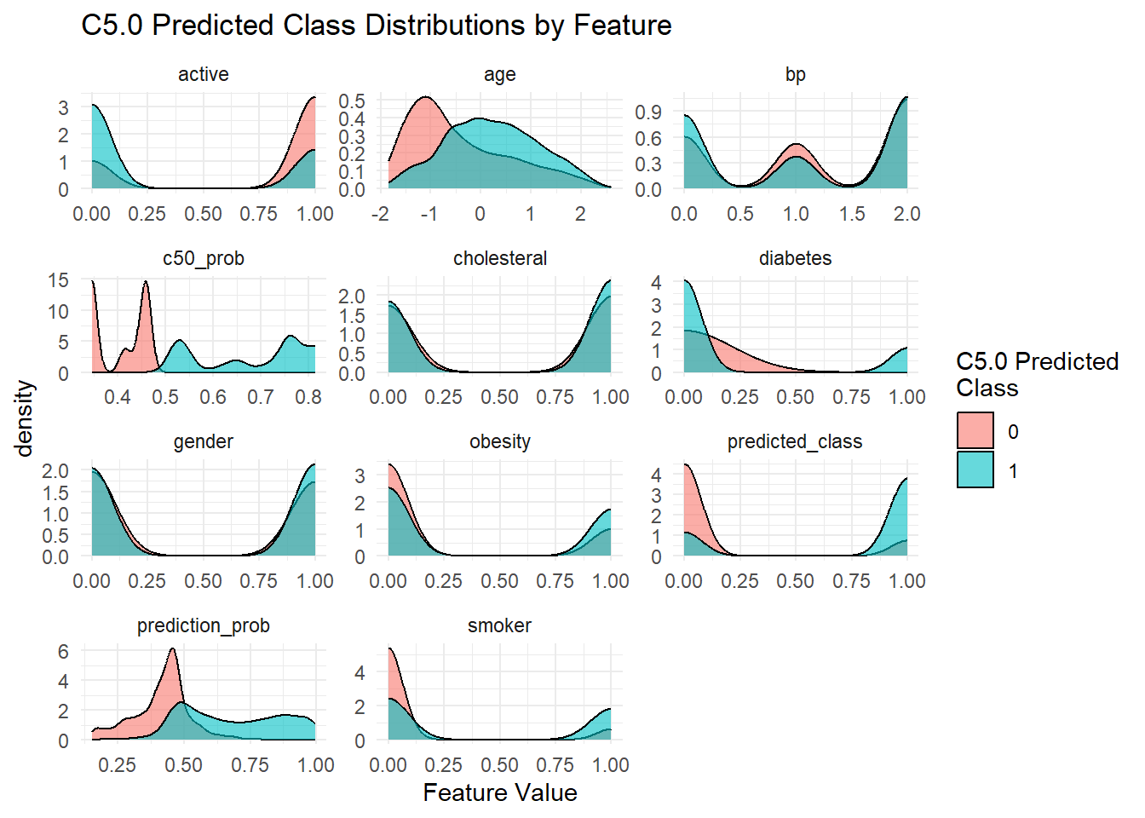
Fig 6. C5.0 feature predictions vs. actuals.
C 5.0 Model
This is the same C5.0 model we built in Homework 6 with 13 splits based on patterns in the data. It correctly predicted heart attack risk about 65% of the time, which is moderate accuracy. The tree was trained on 3,506 cases and made its decisions by breaking the data into smaller groups based on the most useful factors.
The model tended to predict “Yes” (heart attack) more often, and while it did well at catching those who were at risk (1,573 correct), it struggled with false alarms — 726 people were flagged as high risk when they actually weren’t. This shows a bias toward the “Yes” class.
The first and most important factor in the tree was diabetes, which was used in every decision path. It was followed by age, smoking, obesity, and activity level. These are all logical indicators of heart health. Other factors like blood pressure and gender played a smaller role, and cholesterol surprisingly wasn’t used at all, meaning it didn’t help the model make better decisions in this case.
Using the same histogram charting that we did in the neural network model, we can see that cholesterol and gender predictions were very close to overlapping with the actual values.
Overall, the tree is mostly what we’d expect to see: people who are older, diabetic, less active, or smokers are more likely to be predicted as high risk.
Let’s compare the feature importance of the C5.0 model with the neural network model we built earlier.
# Step 1: Add rownames as a column in both
# Extract feature importances from both models
garson_vals <- garson(nn, bar_plot = FALSE) # if not already done
c50imp_vals <- C5imp(model, metric = "usage")

# Add rownames as a column
nn_imp <- garson_vals
nn_imp$variable <- rownames(nn_imp)

c50_imp <- c50imp_vals
c50_imp$variable <- rownames(c50_imp)

# Merge both by variable
feature_comparison <- merge(nn_imp, c50_imp, by = "variable")

# Rename for clarity
colnames(feature_comparison) <- c("Feature", "NeuralNet_Importance", "C5.0_Importance")

# Sort by NeuralNet importance
feature_comparison <- feature_comparison[order(-feature_comparison$NeuralNet_Importance), ]

# Output as a table
knitr::kable(feature_comparison, digits = 3, caption = "Table 1. Feature Importance Comparison: Neural Network vs. C5.0")
Table 1. Feature Importance Comparison: Neural Network vs. C5.0
 | Feature | NeuralNet_Importance | C5.0_Importance
5 | diabetes | 0.352 | 100.00
8 | smoker | 0.155 | 86.25
3 | bp | 0.126 | 12.69
2 | age | 0.113 | 86.25
7 | obesity | 0.091 | 52.57
4 | cholesteral | 0.078 | 0.00
1 | active | 0.052 | 45.49
6 | gender | 0.033 | 4.96
Feature Importance Comparison: Neural Network vs. C5.0
We compared which features mattered most in two different models: a neural network and a decision tree model (C5.0).
Both models agreed on the most important predictor: diabetes. It had the biggest impact in both models, which tells us it’s a strong and consistent indicator of heart attack risk.
After that, the models started to differ:
- Smoking was the second most important feature in both models, though C5.0 tied it with age. The neural network gave slightly more weight to smoking than age.
- Blood pressure was much more important in the neural network than in C5.0. This suggests that while it helped with the prediction, it didn’t provide strong clean splits in the tree model.
- Age was more important in the C5.0 model than in the neural network. This might mean age helped create clear rules for splitting data in the decision tree, even if its overall signal wasn’t as strong in the neural network.
- Obesity and activity level were middle-tier features in both models. They helped, but they weren’t standout predictors.
- Cholesterol showed the biggest disagreement. The neural network thought it had some value, while the C5.0 model gave it zero importance. This could mean cholesterol affects risk in more complex ways that don’t fit into simple yes/no splits.
- Gender was the least important in both models. It didn’t add much predictive value.r.
Now let’s compare the accuracy of the two models overall.
if (!require(caret)) install.packages("caret")
if (!require(pROC)) install.packages("pROC")
library(caret)
library(pROC)

# --- NEURAL NET ---
# Already calculated:
# df_clean$predicted_class
# df_clean$prediction_prob
# df_clean$heartattack_s

nn_cm <- confusionMatrix(
factor(df_clean$predicted_class),
factor(df_clean$heartattack_s),
positive = "1"
)

nn_roc <- roc(response = df_clean$heartattack_s, predictor = df_clean$prediction_prob)
## Setting levels: control = 0, case = 1
## Warning in roc.default(response = df_clean$heartattack_s, predictor =
## df_clean$prediction_prob): Deprecated use a matrix as predictor. Unexpected
## results may be produced, please pass a numeric vector.
## Setting direction: controls < cases
auc_nn <- as.numeric(nn_roc$auc)

# --- C5.0 ---
# Already calculated:
# df_clean$c50_predicted
# df_clean$c50_prob

c50_actual <- factor(df_clean$heartattack_s, levels = c(0, 1))

if (length(unique(c50_actual)) == 2) {
c50_cm <- confusionMatrix(
factor(df_clean$c50_predicted),
c50_actual,
positive = "1"
)
c50_roc <- roc(response = c50_actual, predictor = df_clean$c50_prob)
auc_c50 <- as.numeric(c50_roc$auc)
} else {
warning("C5.0 actual values do not contain both classes (0 and 1). Cannot compute ROC.")
auc_c50 <- NA
c50_cm <- list(
overall = c(Accuracy = NA),
byClass = c(Sensitivity = NA, Specificity = NA)
)
}
## Setting levels: control = 0, case = 1
## Setting direction: controls < cases
# Build the final table using original predictions only
comparison_tbl_metrics <- data.frame(
Metric = c("Accuracy", "Sensitivity", "Specificity", "AUC"),
`Neural Network` = c(
round(as.numeric(nn_cm$overall["Accuracy"]), 3),
round(as.numeric(nn_cm$byClass["Sensitivity"]), 3),
round(as.numeric(nn_cm$byClass["Specificity"]), 3),
round(auc_nn, 3)
),
`C5.0` = c(
round(as.numeric(c50_cm$overall["Accuracy"]), 3),
round(as.numeric(c50_cm$byClass["Sensitivity"]), 3),
round(as.numeric(c50_cm$byClass["Specificity"]), 3),
round(auc_c50, 3)
),
`Better Model` = c(
ifelse(as.numeric(nn_cm$overall["Accuracy"]) > as.numeric(c50_cm$overall["Accuracy"]), "Neural Net", "C5.0"),
ifelse(as.numeric(nn_cm$byClass["Sensitivity"]) > as.numeric(c50_cm$byClass["Sensitivity"]), "Neural Net", "C5.0"),
ifelse(as.numeric(nn_cm$byClass["Specificity"]) > as.numeric(c50_cm$byClass["Specificity"]), "Neural Net", "C5.0"),
ifelse(is.na(auc_c50) || auc_nn > auc_c50, "Neural Net", "C5.0")
),
check.names = FALSE
)

# Render table
knitr::kable(comparison_tbl_metrics, caption = "Table 2. Model Performance Comparison: Neural Network vs. C5.0")
Table 2. Model Performance Comparison: Neural Network vs. C5.0
Metric | Neural Network | C5.0 | Better Model
Accuracy | 0.667 | 0.654 | Neural Net
Sensitivity | 0.687 | 0.763 | C5.0
Specificity | 0.639 | 0.498 | Neural Net
AUC | 0.737 | 0.692 | Neural Net
Neural Network vs. C5.0 Observations
The C5.0 model had an accuracy of 65.4%, which is just below the 66.7% from the neural network. So both models got the outcome right about two-thirds of the time, but the neural net was slightly ahead overall.
In terms of classification performance, C5.0 did better at catching actual heart attack cases—its sensitivity was 76.3%, compared to 68.7% for the neural network. But that came with a trade-off: C5.0 also had a lower specificity at 49.8%, which means it flagged more people incorrectly as high-risk. The neural net was more balanced, with 63.9% specificity, so it had fewer false positives. Its AUC was also higher at 0.737 vs. 0.692, which shows it was more consistent at giving higher scores to people who actually had heart attacks.
These results make sense given how the models work. The neural network learns by adjusting weights and passing signals through activation functions in a hidden layer. It doesn’t follow a clear path like a decision tree does, but it can pick up more complex patterns in the data. I used just one hidden layer with five neurons to keep things simple.
C5.0, like we covered in Lesson 8, builds a decision tree using entropy to decide where to split. Unlike a regular CART model that uses binary splits and the Gini index, C5.0 allows multi-way splits, so the trees can be more detailed. That makes it flexible, but sometimes harder to read when the tree gets big. Since entropy measures how mixed the classes are, C5.0 tries to split the data in ways that reduce that uncertainty the most.
In terms of feature importance, both models agreed that diabetes was the top predictor. But they diverged after that:
- The neural network gave higher weight to smoking, blood pressure, and age, and even assigned some value to cholesterol.
- The C5.0 model also ranked smoking and age highly, but gave zero importance to cholesterol, and slightly downplayed blood pressure.
Features like obesity, activity level, and gender played smaller roles in both models, though with some variation in their order.
So while both models used the same input features and achieved similar results, they differed in how they treated false positives and which patterns they emphasized:
- C5.0 was better at catching actual heart attack cases (higher sensitivity),
- The neural network was better at reducing false alarms (higher specificity) and ranking predictions more accurately (higher AUC),
- And the choice between them depends on the priority: catching as many true cases as possible, or keeping predictions more balanced.
Both approaches have strengths: C5.0 provides interpretable, rule-based decisions as seen in its branching logic, while the neural network captures more subtle patterns but sacrifices transparency in how it reaches its decisions.

3.1 Partitioned Neural Network Model
library(caTools)
## Warning: package 'caTools' was built under R version 4.5.1
set.seed(42) # Reproducibility

# Split with 80% for training
split <- sample.split(df_clean$heartattack_s, SplitRatio = 0.8)

train_data <- subset(df_clean, split == TRUE)
test_data <- subset(df_clean, split == FALSE)

# Rebuild the formula just in case
f <- as.formula(paste("heartattack_s ~", paste(feature_names, collapse = " + ")))

# Train the model
nn_split <- neuralnet(f, data = train_data, hidden = 5, linear.output = FALSE)
plot(nn_split)
# Get predictions on test data
predicted_split <- compute(nn_split, test_data[, feature_names])$net.result

# Convert probabilities to class (0/1)
predicted_class_split <- ifelse(predicted_split > 0.5, 1, 0)

# Confusion matrix and accuracy
conf_mat <- table(Predicted = predicted_class_split, Actual = test_data$heartattack_s)
conf_mat
## Actual
## Predicted 0 1
## 0 155 136
## 1 134 276
# Accuracy
accuracy_test <- mean(predicted_class_split == test_data$heartattack_s)
print(paste("Test Accuracy:", round(accuracy_test * 100, 2), "%"))
## [1] "Test Accuracy: 61.48 %"
# Confusion matrix
conf_mat <- table(Predicted = predicted_class_split, Actual = test_data$heartattack_s)

# Extract values from confusion matrix
tn <- conf_mat[1,1]
fp <- conf_mat[2,1]
fn <- conf_mat[1,2]
tp <- conf_mat[2,2]

# Calculate evaluation metrics
accuracy <- (tp + tn) / (tp + tn + fp + fn)
sensitivity <- tp / (tp + fn)
specificity <- tn / (tn + fp)
roc_obj <- roc(test_data$heartattack_s, as.vector(predicted_split))
## Setting levels: control = 0, case = 1
## Setting direction: controls < cases
auc_val <- auc(roc_obj)

# Create summary table
nn_metrics <- data.frame(
Metric = c("Accuracy", "Sensitivity", "Specificity", "AUC"),
Value = round(c(accuracy, sensitivity, specificity, auc_val), 3)
)

# Display table
knitr::kable(nn_metrics, caption = "Table 3: Neural Network Performance on Test Partition")
Table 3: Neural Network Performance on Test Partition
Metric | Value
Accuracy | 0.615
Sensitivity | 0.670
Specificity | 0.536
AUC | 0.679
Partitioned Neural Network Observations
When I first evaluated the neural network using the full dataset, it reached an accuracy of 66.7%, with a sensitivity of 68.7%, specificity of 63.9%, and an AUC of 0.737. These numbers looked pretty solid and suggested the model was doing a decent job overall.
But once I split the data into 80% for training and 20% for testing, the results weren’t quite as strong. The accuracy dropped to 61.5%, sensitivity dipped to 67.0%, specificity fell to 53.6%, and AUC also went down a bit to 0.679.
This kind of drop isn’t surprising. It happens because the original results were based on the same data the model was trained on, so it had already seen all those patterns. Once we asked it to make predictions on new, unseen data (the test set), it had a harder time. That’s a good reminder that models can sometimes overfit—they do well on familiar data but don’t generalize as well to new situations.
Even though the accuracy went down, this test set performance is more useful. It gives a better idea of how the model might behave in the real world when it’s asked to make predictions on new people or cases.
In short:
- The model looked stronger on the full dataset because it had already “seen” the data.
- Partitioning forced it to make predictions on new data, which is harder.
- The drop confirms that there’s still room to improve the model’s generalization—something we’ll explore through tuning next.

3.2 Tuning the Partitioned Neural Network
# Helper function
min_max_scale <- function(df, mins, maxs) {
as.data.frame(scale(df, center = mins, scale = maxs - mins))
}

# Compute mins and maxs from training data
train_predictors <- train_data[, feature_names]
test_predictors <- test_data[, feature_names]

mins <- apply(train_predictors, 2, min)
maxs <- apply(train_predictors, 2, max)

train_scaled <- min_max_scale(train_predictors, mins, maxs)
test_scaled <- min_max_scale(test_predictors, mins, maxs)

# Reattach target column
train_scaled$heartattack_s <- train_data$heartattack_s
test_scaled$heartattack_s <- test_data$heartattack_s

# Formula setup (you already have this)
f <- as.formula(paste("heartattack_s ~", paste(feature_names, collapse = " + ")))

# Train with: 2 layers of 6 and 3 nodes
set.seed(42)
nn_best <- neuralnet(f,
data = train_scaled,
hidden = c(6, 3),
linear.output = FALSE,
stepmax = 1e6,
rep = 3)

# Find the best rep (lowest error)
best_index <- which.min(nn_best$result.matrix["error", ])

# Predict on scaled test data using best rep
predicted_best <- compute(nn_best, test_scaled[, feature_names], rep = best_index)$net.result
predicted_class_best <- ifelse(predicted_best > 0.5, 1, 0)

# Confusion matrix and accuracy
confusion <- table(Predicted = predicted_class_best, Actual = test_scaled$heartattack_s)
accuracy <- mean(predicted_class_best == test_scaled$heartattack_s)

print(confusion)
## Actual
## Predicted 0 1
## 0 183 161
## 1 106 251
print(paste("Best Rep Test Accuracy:", round(accuracy * 100, 2), "%"))
## [1] "Best Rep Test Accuracy: 61.91 %"
test_scaled$prediction_prob <- predicted_best
test_scaled$predicted_class <- predicted_class_best

ggplot(test_scaled, aes(x = prediction_prob, fill = factor(heartattack_s))) +
geom_histogram(position = "identity", bins = 30, alpha = 0.6) +
labs(title = "Predicted Probabilities (Best Rep)",
x = "Predicted Probability", fill = "Actual Heart Attack") +
theme_minimal()
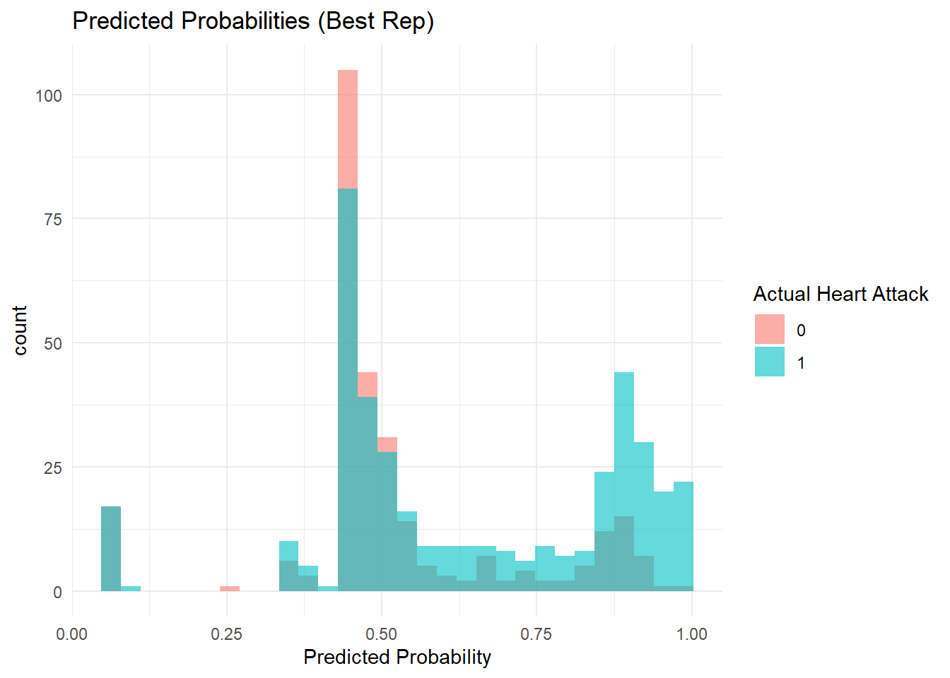
Fig 7. Tuned predictions vs. actuals.
# Plot the neural network
plotnet(nn_best)
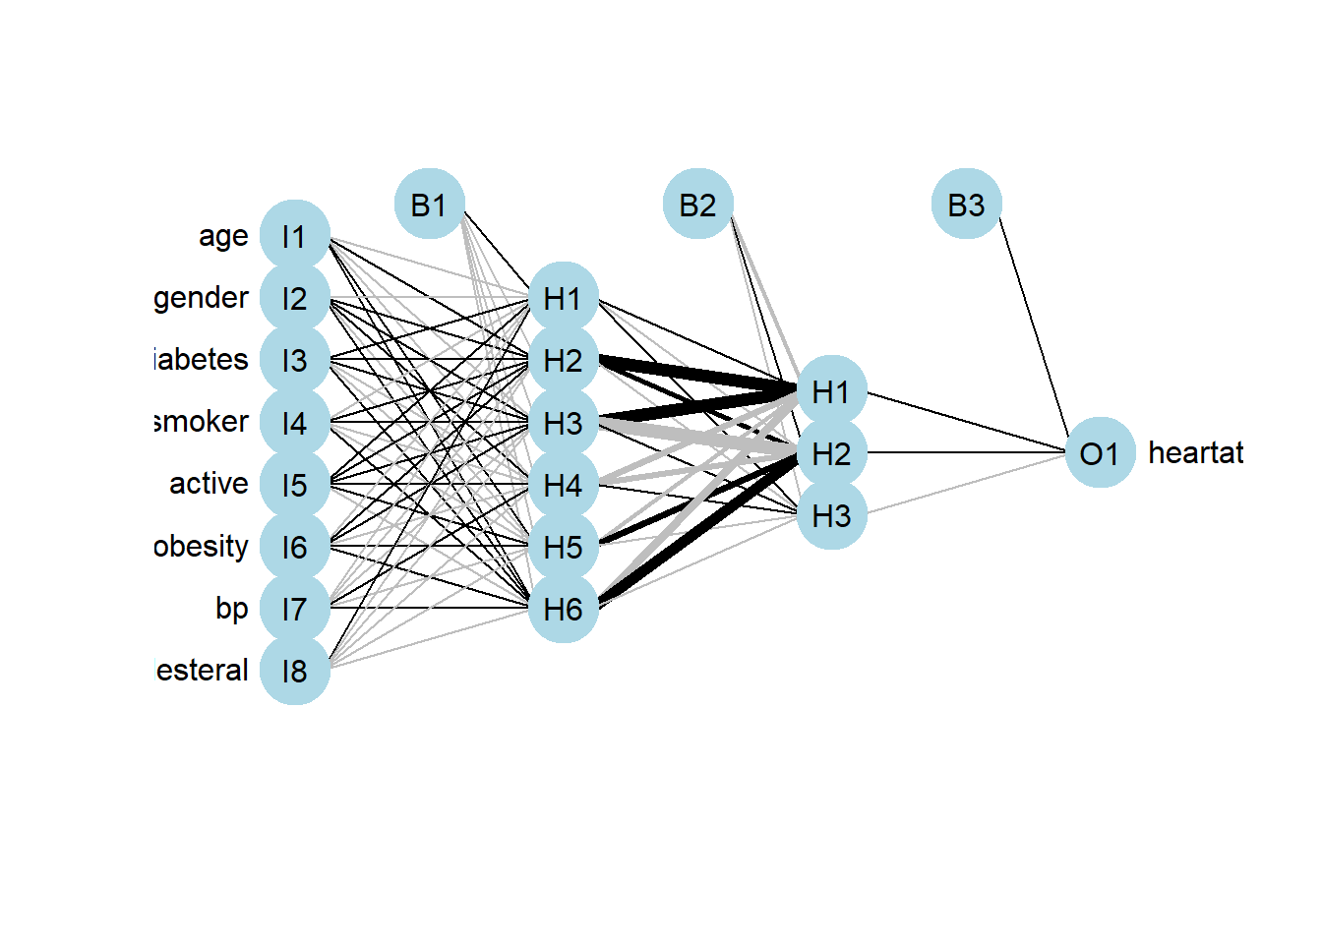
Fig 8. Tuned Partitioned Neural Network Model with a two layers of 6 and 3 nodes.
# Extract values from confusion matrix
tn <- confusion[1,1]
fp <- confusion[2,1]
fn <- confusion[1,2]
tp <- confusion[2,2]

# Metrics for tuned model
accuracy <- (tp + tn) / (tp + tn + fp + fn)
sensitivity <- tp / (tp + fn)
specificity <- tn / (tn + fp)
roc_obj <- roc(test_data$heartattack_s, as.vector(predicted_split))
## Setting levels: control = 0, case = 1
## Setting direction: controls < cases
auc_val <- auc(roc_obj)

# Table for tuned model
tuned_metrics <- data.frame(
Metric = c("Accuracy", "Sensitivity", "Specificity", "AUC"),
Value = round(c(accuracy, sensitivity, specificity, auc_val), 3)
)

knitr::kable(tuned_metrics, caption = "Table 4: Tuned Neural Network Performance on Test Partition")
Table 4: Tuned Neural Network Performance on Test Partition
Metric | Value
Accuracy | 0.619
Sensitivity | 0.609
Specificity | 0.633
AUC | 0.679
Partitioned Neural Network Tuning Observations
After tuning the neural network to use two hidden layers—6 neurons in the first layer and 3 in the second—I saw some small changes in how it performed on the test data.
- Accuracy went up just a bit, from 61.5% to 61.9%.
- Specificity improved quite a bit, from 53.6% to 63.3%, which means the model got better at identifying people who weren’t at risk.
- But sensitivity dropped from 67.0% to 60.9%, so it missed more actual heart attack cases.
- The AUC stayed the same at 0.679, so overall class separation didn’t really improve.
This trade-off is interesting. The tuned model reduced false positives, but it came at the cost of catching fewer true positives. Depending on how the model is used in practice, this could be good or bad—if false alarms are expensive or create unnecessary stress, better specificity might be worth it.
The network diagram (see Fig. 8) also shows the difference in structure. Instead of just one layer of 5 neurons like before, this version has:
- A first hidden layer with 6 neurons
- A second hidden layer with 3 neurons
- More complex, layered connections—some of the black lines are thicker now, which shows where the model found stronger patterns in the data
Overall, the tuning added more depth to the model but didn’t dramatically change its performance. It just shifted the balance between catching more true cases vs. avoiding false one

References For Neural Network Plotting:
- Plotnet: Plot A neural network model. RDocumentation. (n.d.). https://www.rdocumentation.org/packages/NeuralNetTools/versions/1.5.3/topics/plotnet
- Garson: Variable importance using Garson’s algorithm. RDocumentation. (n.d.-a). https://www.rdocumentation.org/packages/NeuralNetTools/versions/1.5.3/topics/garson S

Appendix: Full Code
---
title: "IE 575 Homework 7"
author: "Eric Smith"
date: "`r Sys.Date()`"
output: html_document
---

```{r setup, include=FALSE}
knitr::opts_chunk$set(echo = TRUE)
```

# 1.1 Explore the Data Set and Initial Neural Network Model

**Data Exploration**

```{r data-exploration, include=FALSE}
# Load necessary libraries
if (!requireNamespace("caret", quietly = TRUE)) install.packages("caret")
if (!requireNamespace("C50", quietly = TRUE)) install.packages("C50")
if (!requireNamespace("readxl", quietly = TRUE)) install.packages("readxl")

library(caret)
library(C50)
library(readxl)
library(ggplot2)
library(dplyr)
library(rpart)
library(rpart.plot)
library(pROC)
library(tidyr)
library(NeuralNetTools)
```

```{r}

# Load the dataset
file_path <- "Patient_Data.xlsx"
patient_data <- read_excel(file_path, sheet = "Patient Data")

# Check for missing values and duplicates
na_counts <- sapply(patient_data, function(x) sum(is.na(x)))
print("Missing Values in Each Column:")
print(na_counts)

duplicate_count <- sum(duplicated(patient_data))
print(paste("Number of Duplicate Rows:", duplicate_count))

# Clean and factorize
patient_data <- patient_data[!duplicated(patient_data), ]

categorical_vars <- c("gender", "diabetes", "smoker", "active", "obesity", "heartattack_s", "bp", "cholesteral")
patient_data[categorical_vars] <- lapply(patient_data[categorical_vars], factor)

# Overview
summary(patient_data)
str(patient_data)

```

> **Data Set Observations**
>
> This is the same dataset from the last homework where there were no missing values, but that there were 4,492 duplicate rows.
>
> Variables include age, which is continuous and numeric, and a number of classification variables, such as gender with female and male; diabetes, smoker, active, obesity, heartattack_s (the target variable), all with "Yes" or "No" classes; blood pressure (bp), with three classes that include "Hypertension," "Hypotension," and "Normal"; and and cholesterol with two classes that include "High," and "Normal".
>
> And we initially looked as some charting last time and noted that, as expected, the classic indicators shown in the bar charts above show that expected risks such as diabetes and being a smoker have more observations of heart attack risk.

# 1.2 Create Neural Network Model

```{r nn-model}

# Load the neuralnet package
if (!requireNamespace("neuralnet", quietly = TRUE)) install.packages("neuralnet")
library(neuralnet)

df <- patient_data

# Convert factors to numeric 0/1 (or 1/2/3 for bp)
df_clean <- df %>%
mutate(across(where(is.factor), ~ as.numeric(.) - 1)) # This makes 0 = "No", 1 = "Yes"

# Normalize age
df_clean$age <- scale(df_clean$age, center = TRUE, scale = TRUE)

# Check result
glimpse(df_clean)

# Build formula dynamically
feature_names <- names(df_clean)[names(df_clean) != "heartattack_s"]
f <- as.formula(paste("heartattack_s ~", paste(feature_names, collapse = " + ")))

# Build the neural network (try with one hidden layer of 5 nodes to start)
set.seed(42) # Set for reproducibility
nn <- neuralnet(f, data = df_clean, hidden = 5, linear.output = FALSE)

# Predict using the same data (since no split)
predicted <- compute(nn, df_clean[, feature_names])$net.result

# Convert probabilities to 0/1
predicted_class <- ifelse(predicted > 0.5, 1, 0)

# Confusion matrix and accuracy
table(Predicted = predicted_class, Actual = df_clean$heartattack_s)
mean(predicted_class == df_clean$heartattack_s)

# Calculate accuracy
accuracy <- mean(predicted_class == df_clean$heartattack_s)
print(paste("Neural Network Accuracy:", round(accuracy * 100, 2), "%"))

```

```{r nn-plot}
# Plot the neural network
plotnet(nn)
```
<center>**Fig 1. Initial Neural Network Model with a single hidden layer of 5 nodes.**</center>

```{r}
# overall predictions
df_clean$prediction_prob <- predicted
df_clean$predicted_class <- predicted_class

ggplot(df_clean, aes(x = prediction_prob, fill = factor(heartattack_s))) +
geom_histogram(position = "identity", bins = 30, alpha = 0.6) +
labs(fill = "Actual Heart Attack", x = "Predicted Probability", y = "Count") +
ggtitle("Predicted Probability Distribution by Class")

```
<center>**Fig 2. Neural Network overall predictions vs. actuals.**</center>

```{r nn-full-plot}

# Predictions by feature

# Keep only predictors + prediction
df_long <- df_clean %>%
select(-heartattack_s) %>%
mutate(predicted_class = factor(predicted_class)) %>%
pivot_longer(cols = -predicted_class,
names_to = "variable",
values_to = "value")

ggplot(df_long, aes(x = value, fill = predicted_class)) +
geom_density(alpha = 0.6, position = "identity") +
facet_wrap(~ variable, scales = "free", ncol = 3) +
labs(title = "Distributions of Predicted Classes Across All Features",
x = "Feature Value", fill = "Predicted\nClass") +
theme_minimal()

```
<center>**Fig 3. Neural Network feature predictions vs. actuals.**</center>

```{r}

garson_vals <- garson(nn, bar_plot = FALSE)
print(garson_vals)
olden(nn)

```
<center>**Fig 4. Feature importance from the neural network model.**</center>
```{r}

# Evaluate performance using confusion matrix
nn_cm <- confusionMatrix(
factor(df_clean$predicted_class),
factor(df_clean$heartattack_s),
positive = "1"
)

# ROC and AUC
nn_roc <- roc(
response = df_clean$heartattack_s,
predictor = as.vector(df_clean$prediction_prob) # ensures numeric vector
)
auc_nn <- as.numeric(nn_roc$auc)

# Create a table for the neural network evaluation metrics
nn_eval_tbl <- data.frame(
Metric = c("Accuracy", "Sensitivity", "Specificity", "AUC"),
Value = c(
round(as.numeric(nn_cm$overall["Accuracy"]), 3),
round(as.numeric(nn_cm$byClass["Sensitivity"]), 3),
round(as.numeric(nn_cm$byClass["Specificity"]), 3),
round(auc_nn, 3)
)
)

# Display it as a nicely formatted table
knitr::kable(nn_eval_tbl, caption = "Table 1. Neural Network Model Evaluation Metrics")

```
> **Neural Network Summary**
>
> To start, I created a basic neural network model to predict the likelihood of heart attack using eight input features. I used one hidden layer with five neurons. This simple structure helped keep the model easy to interpret while still giving it some flexibility to capture relationships in the data.
>
> The model reached an accuracy of 66.7%, with a sensitivity of 68.7% and specificity of 63.9%. This means the model was slightly better at identifying people who actually had heart attacks than those who didn’t. The AUC was 0.737, which suggests the model did a decent job overall of separating the two classes.
>
> When I looked at the histogram of predicted probabilities, people who had heart attacks mostly received higher probability scores. But there was still some overlap around the 0.4–0.6 range, where the model wasn’t as confident. These are the borderline cases where it struggled to make clear predictions.
>
> To better understand how the model made decisions, we visualized its architecture and analyzed weight-based feature importance.
>
> That analysis revealed that:
>
> - Diabetes was by far the most influential predictor, contributing over a third of the model’s learned signal.
>
> - Smoking status and blood pressure followed as the next most important features, with age also providing meaningful influence.
>
> - Obesity, cholesterol, and activity level played more modest roles.
>
> - Gender had the least impact on predictions.
>
> Key Observations
>
> - Model Performance: The model correctly classified about two-thirds of all cases. Its higher sensitivity suggests better detection of heart attack risk than avoidance of false alarms.
>
> - Predicted Probabilities: The model generally assigned higher risk scores to actual heart attack cases, though predictions were less certain near the middle probability range. Histogram charting of predictions vs. actuals showed that the gender class had a good overlap in terms of appearing to be the most accurately predicted class.
>
> - Feature Influence: The dominance of diabetes as a predictor, followed by smoking and blood pressure, suggests that lifestyle and medical history factors weigh heavily in the model’s risk assessment.

## 2.1 C5.0 Model

```{r c50-model}
model <- C5.0(heartattack_s ~ ., data = patient_data)
summary(model)
C5imp(model, metric = "usage")

# Predict and confusion matrix
preds <- predict(model, patient_data)
c50_cm <- table(predicted = preds, actual = patient_data$heartattack_s)
c50_accuracy <- mean(preds == patient_data$heartattack_s)

print(c50_cm)
paste("C5.0 Accuracy:", round(c50_accuracy * 100, 2), "%")
```

```{r plot-c50-tree}
# Step 1: Get prediction probabilities from C5.0 model
c50_probs <- predict(model, patient_data, type = "prob")

# Step 2: Add to your cleaned dataset
df_clean$c50_prob <- c50_probs[, 2] # Column 2 is probability of class "Yes"

# Step 3: Plot the predicted probabilities by actual class
ggplot(df_clean, aes(x = c50_prob, fill = factor(heartattack_s))) +
geom_histogram(position = "identity", bins = 30, alpha = 0.6) +
labs(fill = "Actual Heart Attack",
x = "C5.0 Predicted Probability of Heart Attack",
y = "Count") +
ggtitle("C5.0 Predicted Probability Distribution by Actual Class") +
theme_minimal()

```
<center>**Fig 5. C5.0 overall predictions vs. actuals.**</center>
```{r}

# Add predicted class from C5.0
df_clean$c50_predicted <- as.numeric(preds) - 1 # Convert to 0/1

# Pivot to long format for visualization
df_c50_long <- df_clean %>%
mutate(c50_predicted = factor(c50_predicted)) %>%
select(-heartattack_s) %>%
pivot_longer(cols = -c50_predicted,
names_to = "variable",
values_to = "value")

# Plot the cluster grid
ggplot(df_c50_long, aes(x = value, fill = c50_predicted)) +
geom_density(alpha = 0.6, position = "identity") +
facet_wrap(~ variable, scales = "free", ncol = 3) +
labs(title = "C5.0 Predicted Class Distributions by Feature",
x = "Feature Value", fill = "C5.0 Predicted\nClass") +
theme_minimal()

```
<center>**Fig 6. C5.0 feature predictions vs. actuals.**</center>

> **C 5.0 Model**
>
> This is the same C5.0 model we built in Homework 6 with 13 splits based on patterns in the data. It correctly predicted heart attack risk about 65% of the time, which is moderate accuracy. The tree was trained on 3,506 cases and made its decisions by breaking the data into smaller groups based on the most useful factors.
>
> The model tended to predict “Yes” (heart attack) more often, and while it did well at catching those who were at risk (1,573 correct), it struggled with false alarms — 726 people were flagged as high risk when they actually weren’t. This shows a bias toward the “Yes” class.
>
> The first and most important factor in the tree was diabetes, which was used in every decision path. It was followed by age, smoking, obesity, and activity level. These are all logical indicators of heart health. Other factors like blood pressure and gender played a smaller role, and cholesterol surprisingly wasn’t used at all, meaning it didn’t help the model make better decisions in this case.
>
> Using the same histogram charting that we did in the neural network model, we can see that cholesterol and gender predictions were very close to overlapping with the actual values.
>
> Overall, the tree is mostly what we’d expect to see: people who are older, diabetic, less active, or smokers are more likely to be predicted as high risk.
>
> Let's compare the feature importance of the C5.0 model with the neural network model we built earlier.
```{r}
# Step 1: Add rownames as a column in both
# Extract feature importances from both models
garson_vals <- garson(nn, bar_plot = FALSE) # if not already done
c50imp_vals <- C5imp(model, metric = "usage")

# Add rownames as a column
nn_imp <- garson_vals
nn_imp$variable <- rownames(nn_imp)

c50_imp <- c50imp_vals
c50_imp$variable <- rownames(c50_imp)

# Merge both by variable
feature_comparison <- merge(nn_imp, c50_imp, by = "variable")

# Rename for clarity
colnames(feature_comparison) <- c("Feature", "NeuralNet_Importance", "C5.0_Importance")

# Sort by NeuralNet importance
feature_comparison <- feature_comparison[order(-feature_comparison$NeuralNet_Importance), ]

# Output as a table
knitr::kable(feature_comparison, digits = 3, caption = "Table 1. Feature Importance Comparison: Neural Network vs. C5.0")

```

> **Feature Importance Comparison: Neural Network vs. C5.0**
>
> We compared which features mattered most in two different models: a neural network and a decision tree model (C5.0).
>
> Both models agreed on the most important predictor: diabetes. It had the biggest impact in both models, which tells us it's a strong and consistent indicator of heart attack risk.
>
> After that, the models started to differ:
>
> - Smoking was the second most important feature in both models, though C5.0 tied it with age. The neural network gave slightly more weight to smoking than age.
>
> - Blood pressure was much more important in the neural network than in C5.0. This suggests that while it helped with the prediction, it didn’t provide strong clean splits in the tree model.
>
> - Age was more important in the C5.0 model than in the neural network. This might mean age helped create clear rules for splitting data in the decision tree, even if its overall signal wasn’t as strong in the neural network.
>
> - Obesity and activity level were middle-tier features in both models. They helped, but they weren’t standout predictors.
>
> - Cholesterol showed the biggest disagreement. The neural network thought it had some value, while the C5.0 model gave it zero importance. This could mean cholesterol affects risk in more complex ways that don’t fit into simple yes/no splits.
>
> - Gender was the least important in both models. It didn’t add much predictive value.r.
>
Now let's compare the accuracy of the two models overall.

```{r compare-accuracy}

if (!require(caret)) install.packages("caret")
if (!require(pROC)) install.packages("pROC")
library(caret)
library(pROC)

# --- NEURAL NET ---
# Already calculated:
# df_clean$predicted_class
# df_clean$prediction_prob
# df_clean$heartattack_s

nn_cm <- confusionMatrix(
factor(df_clean$predicted_class),
factor(df_clean$heartattack_s),
positive = "1"
)

nn_roc <- roc(response = df_clean$heartattack_s, predictor = df_clean$prediction_prob)
auc_nn <- as.numeric(nn_roc$auc)

# --- C5.0 ---
# Already calculated:
# df_clean$c50_predicted
# df_clean$c50_prob

c50_actual <- factor(df_clean$heartattack_s, levels = c(0, 1))

if (length(unique(c50_actual)) == 2) {
c50_cm <- confusionMatrix(
factor(df_clean$c50_predicted),
c50_actual,
positive = "1"
)
c50_roc <- roc(response = c50_actual, predictor = df_clean$c50_prob)
auc_c50 <- as.numeric(c50_roc$auc)
} else {
warning("C5.0 actual values do not contain both classes (0 and 1). Cannot compute ROC.")
auc_c50 <- NA
c50_cm <- list(
overall = c(Accuracy = NA),
byClass = c(Sensitivity = NA, Specificity = NA)
)
}

# Build the final table using original predictions only
comparison_tbl_metrics <- data.frame(
Metric = c("Accuracy", "Sensitivity", "Specificity", "AUC"),
`Neural Network` = c(
round(as.numeric(nn_cm$overall["Accuracy"]), 3),
round(as.numeric(nn_cm$byClass["Sensitivity"]), 3),
round(as.numeric(nn_cm$byClass["Specificity"]), 3),
round(auc_nn, 3)
),
`C5.0` = c(
round(as.numeric(c50_cm$overall["Accuracy"]), 3),
round(as.numeric(c50_cm$byClass["Sensitivity"]), 3),
round(as.numeric(c50_cm$byClass["Specificity"]), 3),
round(auc_c50, 3)
),
`Better Model` = c(
ifelse(as.numeric(nn_cm$overall["Accuracy"]) > as.numeric(c50_cm$overall["Accuracy"]), "Neural Net", "C5.0"),
ifelse(as.numeric(nn_cm$byClass["Sensitivity"]) > as.numeric(c50_cm$byClass["Sensitivity"]), "Neural Net", "C5.0"),
ifelse(as.numeric(nn_cm$byClass["Specificity"]) > as.numeric(c50_cm$byClass["Specificity"]), "Neural Net", "C5.0"),
ifelse(is.na(auc_c50) || auc_nn > auc_c50, "Neural Net", "C5.0")
),
check.names = FALSE
)

# Render table
knitr::kable(comparison_tbl_metrics, caption = "Table 2. Model Performance Comparison: Neural Network vs. C5.0")

```

> **Neural Network vs. C5.0 Observations**
>
> The C5.0 model had an accuracy of 65.4%, which is just below the 66.7% from the neural network. So both models got the outcome right about two-thirds of the time, but the neural net was slightly ahead overall.
>
> In terms of classification performance, C5.0 did better at catching actual heart attack cases—its sensitivity was 76.3%, compared to 68.7% for the neural network. But that came with a trade-off: C5.0 also had a lower specificity at 49.8%, which means it flagged more people incorrectly as high-risk. The neural net was more balanced, with 63.9% specificity, so it had fewer false positives. Its AUC was also higher at 0.737 vs. 0.692, which shows it was more consistent at giving higher scores to people who actually had heart attacks.
>
> These results make sense given how the models work. The neural network learns by adjusting weights and passing signals through activation functions in a hidden layer. It doesn’t follow a clear path like a decision tree does, but it can pick up more complex patterns in the data. I used just one hidden layer with five neurons to keep things simple.
>
> C5.0, like we covered in Lesson 8, builds a decision tree using entropy to decide where to split. Unlike a regular CART model that uses binary splits and the Gini index, C5.0 allows multi-way splits, so the trees can be more detailed. That makes it flexible, but sometimes harder to read when the tree gets big. Since entropy measures how mixed the classes are, C5.0 tries to split the data in ways that reduce that uncertainty the most.
>
> In terms of feature importance, both models agreed that diabetes was the top predictor. But they diverged after that:
>
> - The neural network gave higher weight to smoking, blood pressure, and age, and even assigned some value to cholesterol.
>
> - The C5.0 model also ranked smoking and age highly, but gave zero importance to cholesterol, and slightly downplayed blood pressure.
>
> Features like obesity, activity level, and gender played smaller roles in both models, though with some variation in their order.
>
> So while both models used the same input features and achieved similar results, they differed in how they treated false positives and which patterns they emphasized:
>
> - C5.0 was better at catching actual heart attack cases (higher sensitivity),
>
> - The neural network was better at reducing false alarms (higher specificity) and ranking predictions more accurately (higher AUC),
>
> - And the choice between them depends on the priority: catching as many true cases as possible, or keeping predictions more balanced.
>
> Both approaches have strengths: C5.0 provides interpretable, rule-based decisions as seen in its branching logic, while the neural network captures more subtle patterns but sacrifices transparency in how it reaches its decisions.

# 3.1 Partitioned Neural Network Model

```{r partitioned}
library(caTools)

set.seed(42) # Reproducibility

# Split with 80% for training
split <- sample.split(df_clean$heartattack_s, SplitRatio = 0.8)

train_data <- subset(df_clean, split == TRUE)
test_data <- subset(df_clean, split == FALSE)

# Rebuild the formula just in case
f <- as.formula(paste("heartattack_s ~", paste(feature_names, collapse = " + ")))

# Train the model
nn_split <- neuralnet(f, data = train_data, hidden = 5, linear.output = FALSE)
plot(nn_split)

```

```{r}
# Get predictions on test data
predicted_split <- compute(nn_split, test_data[, feature_names])$net.result

# Convert probabilities to class (0/1)
predicted_class_split <- ifelse(predicted_split > 0.5, 1, 0)

# Confusion matrix and accuracy
conf_mat <- table(Predicted = predicted_class_split, Actual = test_data$heartattack_s)
conf_mat

# Accuracy
accuracy_test <- mean(predicted_class_split == test_data$heartattack_s)
print(paste("Test Accuracy:", round(accuracy_test * 100, 2), "%"))
# Confusion matrix
conf_mat <- table(Predicted = predicted_class_split, Actual = test_data$heartattack_s)

# Extract values from confusion matrix
tn <- conf_mat[1,1]
fp <- conf_mat[2,1]
fn <- conf_mat[1,2]
tp <- conf_mat[2,2]

# Calculate evaluation metrics
accuracy <- (tp + tn) / (tp + tn + fp + fn)
sensitivity <- tp / (tp + fn)
specificity <- tn / (tn + fp)
roc_obj <- roc(test_data$heartattack_s, as.vector(predicted_split))
auc_val <- auc(roc_obj)

# Create summary table
nn_metrics <- data.frame(
Metric = c("Accuracy", "Sensitivity", "Specificity", "AUC"),
Value = round(c(accuracy, sensitivity, specificity, auc_val), 3)
)

# Display table
knitr::kable(nn_metrics, caption = "Table 3: Neural Network Performance on Test Partition")

```

> **Partitioned Neural Network Observations**
>
> When I first evaluated the neural network using the full dataset, it reached an accuracy of 66.7%, with a sensitivity of 68.7%, specificity of 63.9%, and an AUC of 0.737. These numbers looked pretty solid and suggested the model was doing a decent job overall.
>
> But once I split the data into 80% for training and 20% for testing, the results weren’t quite as strong. The accuracy dropped to 61.5%, sensitivity dipped to 67.0%, specificity fell to 53.6%, and AUC also went down a bit to 0.679.
>
> This kind of drop isn’t surprising. It happens because the original results were based on the same data the model was trained on, so it had already seen all those patterns. Once we asked it to make predictions on new, unseen data (the test set), it had a harder time. That’s a good reminder that models can sometimes overfit—they do well on familiar data but don’t generalize as well to new situations.
>
> Even though the accuracy went down, this test set performance is more useful. It gives a better idea of how the model might behave in the real world when it’s asked to make predictions on new people or cases.
>
> In short:
>
> - The model looked stronger on the full dataset because it had already “seen” the data.
>
> - Partitioning forced it to make predictions on new data, which is harder.
>
> - The drop confirms that there's still room to improve the model’s generalization—something we’ll explore through tuning next.

# 3.2 Tuning the Partitioned Neural Network

```{r tuning}
# Helper function
min_max_scale <- function(df, mins, maxs) {
as.data.frame(scale(df, center = mins, scale = maxs - mins))
}

# Compute mins and maxs from training data
train_predictors <- train_data[, feature_names]
test_predictors <- test_data[, feature_names]

mins <- apply(train_predictors, 2, min)
maxs <- apply(train_predictors, 2, max)

train_scaled <- min_max_scale(train_predictors, mins, maxs)
test_scaled <- min_max_scale(test_predictors, mins, maxs)

# Reattach target column
train_scaled$heartattack_s <- train_data$heartattack_s
test_scaled$heartattack_s <- test_data$heartattack_s

# Formula setup (you already have this)
f <- as.formula(paste("heartattack_s ~", paste(feature_names, collapse = " + ")))

# Train with: 2 layers of 6 and 3 nodes
set.seed(42)
nn_best <- neuralnet(f,
data = train_scaled,
hidden = c(6, 3),
linear.output = FALSE,
stepmax = 1e6,
rep = 3)

# Find the best rep (lowest error)
best_index <- which.min(nn_best$result.matrix["error", ])

# Predict on scaled test data using best rep
predicted_best <- compute(nn_best, test_scaled[, feature_names], rep = best_index)$net.result
predicted_class_best <- ifelse(predicted_best > 0.5, 1, 0)

# Confusion matrix and accuracy
confusion <- table(Predicted = predicted_class_best, Actual = test_scaled$heartattack_s)
accuracy <- mean(predicted_class_best == test_scaled$heartattack_s)

print(confusion)
print(paste("Best Rep Test Accuracy:", round(accuracy * 100, 2), "%"))

```

```{r plot-best-rep}

test_scaled$prediction_prob <- predicted_best
test_scaled$predicted_class <- predicted_class_best

ggplot(test_scaled, aes(x = prediction_prob, fill = factor(heartattack_s))) +
geom_histogram(position = "identity", bins = 30, alpha = 0.6) +
labs(title = "Predicted Probabilities (Best Rep)",
x = "Predicted Probability", fill = "Actual Heart Attack") +
theme_minimal()

```
<center>**Fig 7. Tuned predictions vs. actuals.**</center>

```{r nn-plot-2}
# Plot the neural network
plotnet(nn_best)
```
<center>**Fig 8. Tuned Partitioned Neural Network Model with a two layers of 6 and 3 nodes.**</center>

```{r nn-plot-2-full, eval}

# Extract values from confusion matrix
tn <- confusion[1,1]
fp <- confusion[2,1]
fn <- confusion[1,2]
tp <- confusion[2,2]

# Metrics for tuned model
accuracy <- (tp + tn) / (tp + tn + fp + fn)
sensitivity <- tp / (tp + fn)
specificity <- tn / (tn + fp)
roc_obj <- roc(test_data$heartattack_s, as.vector(predicted_split))
auc_val <- auc(roc_obj)

# Table for tuned model
tuned_metrics <- data.frame(
Metric = c("Accuracy", "Sensitivity", "Specificity", "AUC"),
Value = round(c(accuracy, sensitivity, specificity, auc_val), 3)
)

knitr::kable(tuned_metrics, caption = "Table 4: Tuned Neural Network Performance on Test Partition")

```

> **Partitioned Neural Network Tuning Observations**
>
> After tuning the neural network to use two hidden layers—6 neurons in the first layer and 3 in the second—I saw some small changes in how it performed on the test data.
>
> - Accuracy went up just a bit, from 61.5% to 61.9%.
>
> - Specificity improved quite a bit, from 53.6% to 63.3%, which means the model got better at identifying people who weren’t at risk.
>
> - But sensitivity dropped from 67.0% to 60.9%, so it missed more actual heart attack cases.
>
> - The AUC stayed the same at 0.679, so overall class separation didn’t really improve.
>
> This trade-off is interesting. The tuned model reduced false positives, but it came at the cost of catching fewer true positives. Depending on how the model is used in practice, this could be good or bad—if false alarms are expensive or create unnecessary stress, better specificity might be worth it.
>
> The network diagram (see Fig. 8) also shows the difference in structure. Instead of just one layer of 5 neurons like before, this version has:
>
> - A first hidden layer with 6 neurons
>
> - A second hidden layer with 3 neurons
>
> - More complex, layered connections—some of the black lines are thicker now, which shows where the model found stronger patterns in the data
>
> Overall, the tuning added more depth to the model but didn’t dramatically change its performance. It just shifted the balance between catching more true cases vs. avoiding false one

# References For Neural Network Plotting:
>
> - Plotnet: Plot A neural network model. RDocumentation. (n.d.). https://www.rdocumentation.org/packages/NeuralNetTools/versions/1.5.3/topics/plotnet
>
> - Garson: Variable importance using Garson’s algorithm. RDocumentation. (n.d.-a). https://www.rdocumentation.org/packages/NeuralNetTools/versions/1.5.3/topics/garson S
>

